Gerry Su #16325043

EECS 118

Professor Sheu

**Geometry Problem Progress Report 11-1-2018**

Submit the program you have done so far with a brief description of the program as well as the challenges you are facing.

Brief Description of the Program: So far, does nothing but create the problem1 class.

For this week, I have created the data structure and general skeleton for my approach in the geometry problem. I will have a class for each problem.

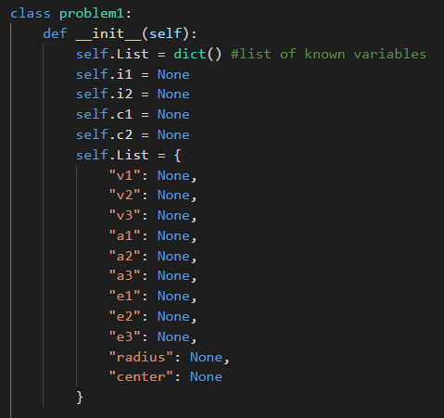

I have implemented the required Input and Output methods.

Input:

**set_value(name, value) and set_vertex(name, x, y) to receive the inputs. It will take in degrees as an input for angles.**

Output:

**For output methods, please only use the following: get_value(name) and get_all().**

I have not yet considered short line segments, arc lengths, small areas, and perimeters in my program.

Going on further, I will establish the algorithm I want to use in main() and attempt to solve for the many variables.

Challenges: Solving for many unknowns given limited amount of information.